Bernoly_simulation

Mehrab Atighi

3/2/2022

set.seed(124)  
prob = c(0.1 , 0.3 , 0.5 , 0.7 , 0.9)  
s = 1  
n = c(5 ,10 , 30 , 50 , 100 , 150)  
r = 500000  
for(j in 1:length(prob)){  
for(i in 1:length(n)){  
D = matrix(rbinom(n = n[i] * r , size = s , prob = prob[j]) ,  
 ncol = r , nrow = n[i])  
  
Xbar = colMeans(D)  
print(paste("for prob = ", prob[j] ," n = ",n[i] ))  
hist(Xbar , breaks = 100 , freq = F)  
curve(dnorm(x , s * prob[j] , sqrt(prob[j] * n[i] * (1-prob[j]) / n[i] )) ,  
 col = 2 , add = T , lwd = 5)  
  
print(paste("the mean of x bar for prob = ", prob[j] ," n = ",n[i] ,"is : " , mean(Xbar)))  
print(paste("the mean of x distribution for prob = ", prob[j] ," n = ",n[i] ,"is : " , (m = s * prob[j])))  
  
print(paste("the variance of x bar for prob = ", prob[j] ," n = ",n[i] ,"is : "  
 , (var(Xbar))))  
print(paste("the variance of x distribution for prob = ", prob[j] ," n = ",n[i] ,"is :"  
 , (v = (prob[j] * s *(1-prob[j]) / n ))))  
}  
}

## [1] "for prob = 0.1 n = 5"

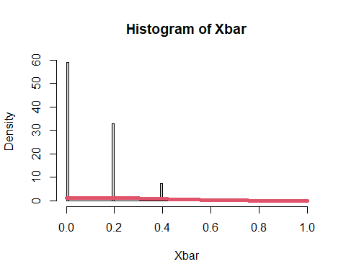

## [1] "the mean of x bar for prob = 0.1 n = 5 is : 0.100142"  
## [1] "the mean of x distribution for prob = 0.1 n = 5 is : 0.1"  
## [1] "the variance of x bar for prob = 0.1 n = 5 is : 0.0180060958481917"  
## [1] "the variance of x distribution for prob = 0.1 n = 5 is : 0.018"   
## [2] "the variance of x distribution for prob = 0.1 n = 5 is : 0.009"   
## [3] "the variance of x distribution for prob = 0.1 n = 5 is : 0.003"   
## [4] "the variance of x distribution for prob = 0.1 n = 5 is : 0.0018"  
## [5] "the variance of x distribution for prob = 0.1 n = 5 is : 9e-04"   
## [6] "the variance of x distribution for prob = 0.1 n = 5 is : 6e-04"   
## [1] "for prob = 0.1 n = 10"

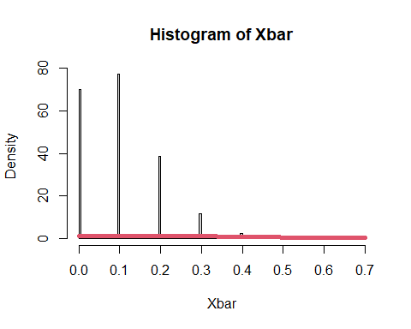

## [1] "the mean of x bar for prob = 0.1 n = 10 is : 0.0999824"  
## [1] "the mean of x distribution for prob = 0.1 n = 10 is : 0.1"  
## [1] "the variance of x bar for prob = 0.1 n = 10 is : 0.00903677776379555"  
## [1] "the variance of x distribution for prob = 0.1 n = 10 is : 0.018"   
## [2] "the variance of x distribution for prob = 0.1 n = 10 is : 0.009"   
## [3] "the variance of x distribution for prob = 0.1 n = 10 is : 0.003"   
## [4] "the variance of x distribution for prob = 0.1 n = 10 is : 0.0018"  
## [5] "the variance of x distribution for prob = 0.1 n = 10 is : 9e-04"   
## [6] "the variance of x distribution for prob = 0.1 n = 10 is : 6e-04"   
## [1] "for prob = 0.1 n = 30"

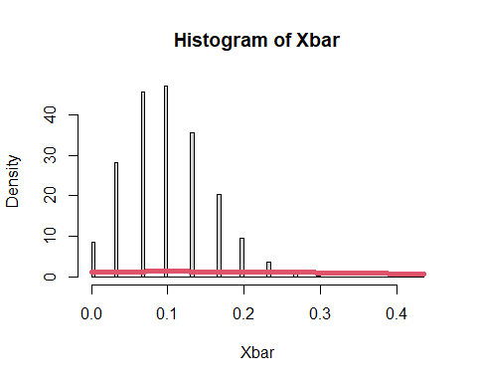

## [1] "the mean of x bar for prob = 0.1 n = 30 is : 0.0999548666666667"  
## [1] "the mean of x distribution for prob = 0.1 n = 30 is : 0.1"  
## [1] "the variance of x bar for prob = 0.1 n = 30 is : 0.00299931729495015"  
## [1] "the variance of x distribution for prob = 0.1 n = 30 is : 0.018"   
## [2] "the variance of x distribution for prob = 0.1 n = 30 is : 0.009"   
## [3] "the variance of x distribution for prob = 0.1 n = 30 is : 0.003"   
## [4] "the variance of x distribution for prob = 0.1 n = 30 is : 0.0018"  
## [5] "the variance of x distribution for prob = 0.1 n = 30 is : 9e-04"   
## [6] "the variance of x distribution for prob = 0.1 n = 30 is : 6e-04"   
## [1] "for prob = 0.1 n = 50"

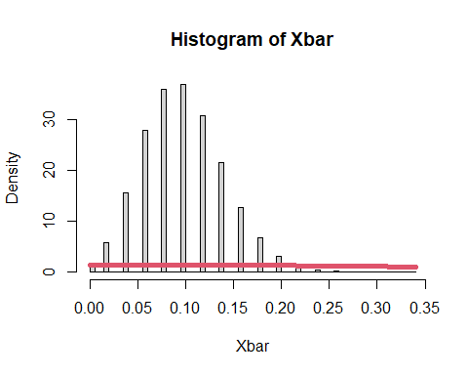

## [1] "the mean of x bar for prob = 0.1 n = 50 is : 0.09993824"  
## [1] "the mean of x distribution for prob = 0.1 n = 50 is : 0.1"  
## [1] "the variance of x bar for prob = 0.1 n = 50 is : 0.00179924458419157"  
## [1] "the variance of x distribution for prob = 0.1 n = 50 is : 0.018"   
## [2] "the variance of x distribution for prob = 0.1 n = 50 is : 0.009"   
## [3] "the variance of x distribution for prob = 0.1 n = 50 is : 0.003"   
## [4] "the variance of x distribution for prob = 0.1 n = 50 is : 0.0018"  
## [5] "the variance of x distribution for prob = 0.1 n = 50 is : 9e-04"   
## [6] "the variance of x distribution for prob = 0.1 n = 50 is : 6e-04"   
## [1] "for prob = 0.1 n = 100"

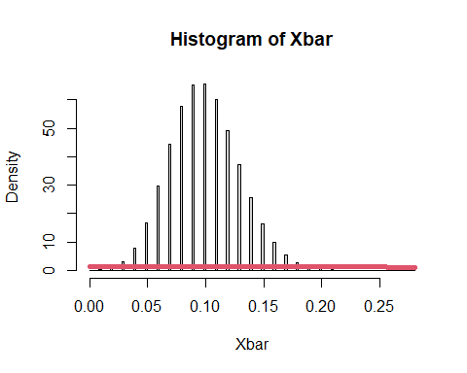

## [1] "the mean of x bar for prob = 0.1 n = 100 is : 0.10002698"  
## [1] "the mean of x distribution for prob = 0.1 n = 100 is : 0.1"  
## [1] "the variance of x bar for prob = 0.1 n = 100 is : 0.000901003674086947"  
## [1] "the variance of x distribution for prob = 0.1 n = 100 is : 0.018"   
## [2] "the variance of x distribution for prob = 0.1 n = 100 is : 0.009"   
## [3] "the variance of x distribution for prob = 0.1 n = 100 is : 0.003"   
## [4] "the variance of x distribution for prob = 0.1 n = 100 is : 0.0018"  
## [5] "the variance of x distribution for prob = 0.1 n = 100 is : 9e-04"   
## [6] "the variance of x distribution for prob = 0.1 n = 100 is : 6e-04"   
## [1] "for prob = 0.1 n = 150"

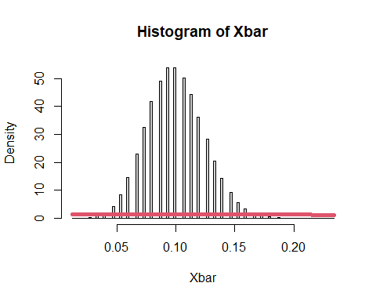

## [1] "the mean of x bar for prob = 0.1 n = 150 is : 0.10004812"  
## [1] "the mean of x distribution for prob = 0.1 n = 150 is : 0.1"  
## [1] "the variance of x bar for prob = 0.1 n = 150 is : 0.000601978532867111"  
## [1] "the variance of x distribution for prob = 0.1 n = 150 is : 0.018"   
## [2] "the variance of x distribution for prob = 0.1 n = 150 is : 0.009"   
## [3] "the variance of x distribution for prob = 0.1 n = 150 is : 0.003"   
## [4] "the variance of x distribution for prob = 0.1 n = 150 is : 0.0018"  
## [5] "the variance of x distribution for prob = 0.1 n = 150 is : 9e-04"   
## [6] "the variance of x distribution for prob = 0.1 n = 150 is : 6e-04"   
## [1] "for prob = 0.3 n = 5"

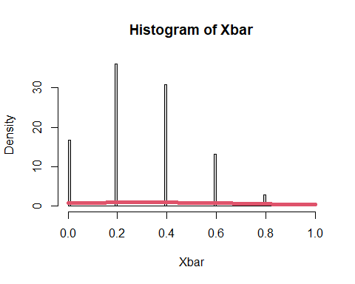

## [1] "the mean of x bar for prob = 0.3 n = 5 is : 0.299938"  
## [1] "the mean of x distribution for prob = 0.3 n = 5 is : 0.3"  
## [1] "the variance of x bar for prob = 0.3 n = 5 is : 0.0420367202294404"  
## [1] "the variance of x distribution for prob = 0.3 n = 5 is : 0.042"   
## [2] "the variance of x distribution for prob = 0.3 n = 5 is : 0.021"   
## [3] "the variance of x distribution for prob = 0.3 n = 5 is : 0.007"   
## [4] "the variance of x distribution for prob = 0.3 n = 5 is : 0.0042"  
## [5] "the variance of x distribution for prob = 0.3 n = 5 is : 0.0021"  
## [6] "the variance of x distribution for prob = 0.3 n = 5 is : 0.0014"  
## [1] "for prob = 0.3 n = 10"

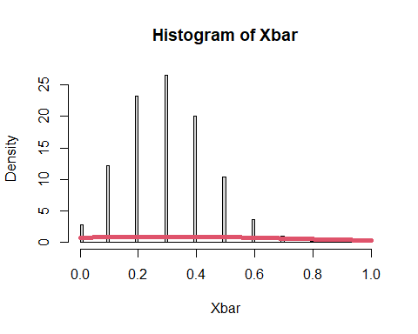

## [1] "the mean of x bar for prob = 0.3 n = 10 is : 0.2998804"  
## [1] "the mean of x distribution for prob = 0.3 n = 10 is : 0.3"  
## [1] "the variance of x bar for prob = 0.3 n = 10 is : 0.0210313477585355"  
## [1] "the variance of x distribution for prob = 0.3 n = 10 is : 0.042"   
## [2] "the variance of x distribution for prob = 0.3 n = 10 is : 0.021"   
## [3] "the variance of x distribution for prob = 0.3 n = 10 is : 0.007"   
## [4] "the variance of x distribution for prob = 0.3 n = 10 is : 0.0042"  
## [5] "the variance of x distribution for prob = 0.3 n = 10 is : 0.0021"  
## [6] "the variance of x distribution for prob = 0.3 n = 10 is : 0.0014"  
## [1] "for prob = 0.3 n = 30"

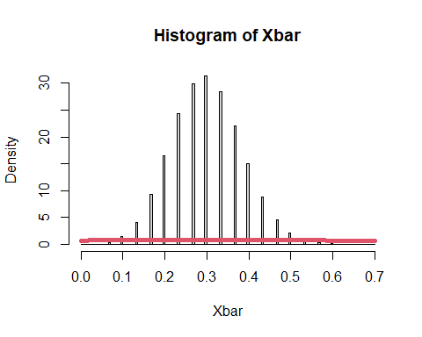

## [1] "the mean of x bar for prob = 0.3 n = 30 is : 0.300133466666667"  
## [1] "the mean of x distribution for prob = 0.3 n = 30 is : 0.3"  
## [1] "the variance of x bar for prob = 0.3 n = 30 is : 0.00701359176938797"  
## [1] "the variance of x distribution for prob = 0.3 n = 30 is : 0.042"   
## [2] "the variance of x distribution for prob = 0.3 n = 30 is : 0.021"   
## [3] "the variance of x distribution for prob = 0.3 n = 30 is : 0.007"   
## [4] "the variance of x distribution for prob = 0.3 n = 30 is : 0.0042"  
## [5] "the variance of x distribution for prob = 0.3 n = 30 is : 0.0021"  
## [6] "the variance of x distribution for prob = 0.3 n = 30 is : 0.0014"  
## [1] "for prob = 0.3 n = 50"

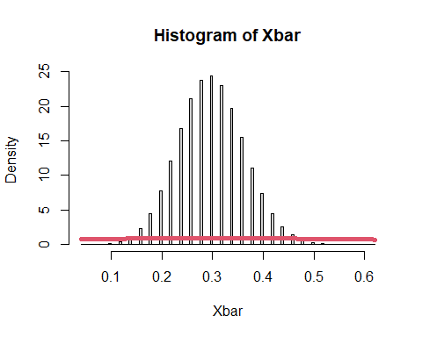

## [1] "the mean of x bar for prob = 0.3 n = 50 is : 0.2997812"  
## [1] "the mean of x distribution for prob = 0.3 n = 50 is : 0.3"  
## [1] "the variance of x bar for prob = 0.3 n = 50 is : 0.00419708852073704"  
## [1] "the variance of x distribution for prob = 0.3 n = 50 is : 0.042"   
## [2] "the variance of x distribution for prob = 0.3 n = 50 is : 0.021"   
## [3] "the variance of x distribution for prob = 0.3 n = 50 is : 0.007"   
## [4] "the variance of x distribution for prob = 0.3 n = 50 is : 0.0042"  
## [5] "the variance of x distribution for prob = 0.3 n = 50 is : 0.0021"  
## [6] "the variance of x distribution for prob = 0.3 n = 50 is : 0.0014"  
## [1] "for prob = 0.3 n = 100"

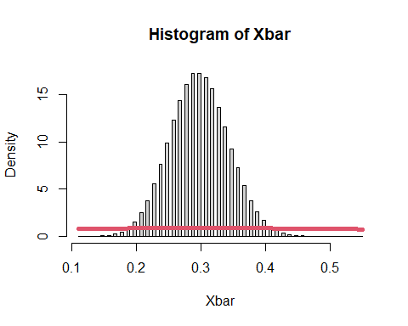

## [1] "the mean of x bar for prob = 0.3 n = 100 is : 0.29998218"  
## [1] "the mean of x distribution for prob = 0.3 n = 100 is : 0.3"  
## [1] "the variance of x bar for prob = 0.3 n = 100 is : 0.00210007368259497"  
## [1] "the variance of x distribution for prob = 0.3 n = 100 is : 0.042"   
## [2] "the variance of x distribution for prob = 0.3 n = 100 is : 0.021"   
## [3] "the variance of x distribution for prob = 0.3 n = 100 is : 0.007"   
## [4] "the variance of x distribution for prob = 0.3 n = 100 is : 0.0042"  
## [5] "the variance of x distribution for prob = 0.3 n = 100 is : 0.0021"  
## [6] "the variance of x distribution for prob = 0.3 n = 100 is : 0.0014"  
## [1] "for prob = 0.3 n = 150"

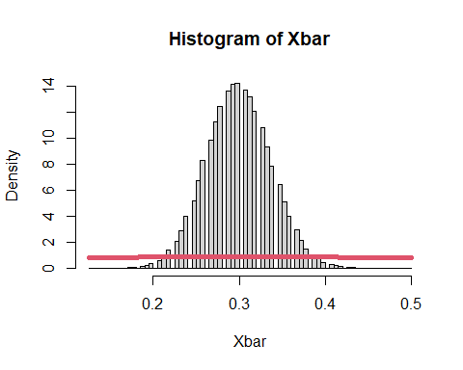

## [1] "the mean of x bar for prob = 0.3 n = 150 is : 0.300043093333333"  
## [1] "the mean of x distribution for prob = 0.3 n = 150 is : 0.3"  
## [1] "the variance of x bar for prob = 0.3 n = 150 is : 0.00140399792873826"  
## [1] "the variance of x distribution for prob = 0.3 n = 150 is : 0.042"   
## [2] "the variance of x distribution for prob = 0.3 n = 150 is : 0.021"   
## [3] "the variance of x distribution for prob = 0.3 n = 150 is : 0.007"   
## [4] "the variance of x distribution for prob = 0.3 n = 150 is : 0.0042"  
## [5] "the variance of x distribution for prob = 0.3 n = 150 is : 0.0021"  
## [6] "the variance of x distribution for prob = 0.3 n = 150 is : 0.0014"  
## [1] "for prob = 0.5 n = 5"

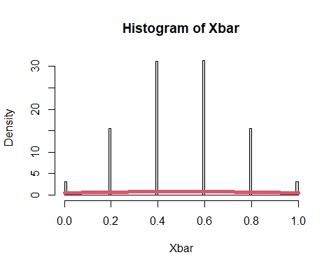

## [1] "the mean of x bar for prob = 0.5 n = 5 is : 0.5004592"  
## [1] "the mean of x distribution for prob = 0.5 n = 5 is : 0.5"  
## [1] "the variance of x bar for prob = 0.5 n = 5 is : 0.0498931689216978"  
## [1] "the variance of x distribution for prob = 0.5 n = 5 is : 0.05"   
## [2] "the variance of x distribution for prob = 0.5 n = 5 is : 0.025"   
## [3] "the variance of x distribution for prob = 0.5 n = 5 is : 0.00833333333333333"  
## [4] "the variance of x distribution for prob = 0.5 n = 5 is : 0.005"   
## [5] "the variance of x distribution for prob = 0.5 n = 5 is : 0.0025"   
## [6] "the variance of x distribution for prob = 0.5 n = 5 is : 0.00166666666666667"  
## [1] "for prob = 0.5 n = 10"

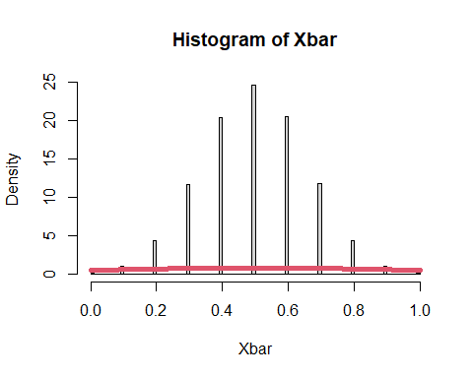

## [1] "the mean of x bar for prob = 0.5 n = 10 is : 0.5002264"  
## [1] "the mean of x distribution for prob = 0.5 n = 10 is : 0.5"  
## [1] "the variance of x bar for prob = 0.5 n = 10 is : 0.0249906787243974"  
## [1] "the variance of x distribution for prob = 0.5 n = 10 is : 0.05"   
## [2] "the variance of x distribution for prob = 0.5 n = 10 is : 0.025"   
## [3] "the variance of x distribution for prob = 0.5 n = 10 is : 0.00833333333333333"  
## [4] "the variance of x distribution for prob = 0.5 n = 10 is : 0.005"   
## [5] "the variance of x distribution for prob = 0.5 n = 10 is : 0.0025"   
## [6] "the variance of x distribution for prob = 0.5 n = 10 is : 0.00166666666666667"  
## [1] "for prob = 0.5 n = 30"

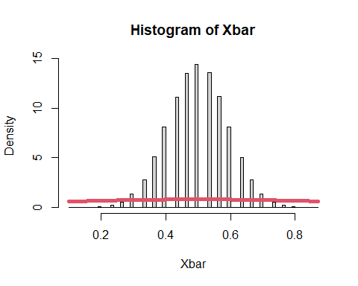

## [1] "the mean of x bar for prob = 0.5 n = 30 is : 0.499948333333333"  
## [1] "the mean of x distribution for prob = 0.5 n = 30 is : 0.5"  
## [1] "the variance of x bar for prob = 0.5 n = 30 is : 0.00834327401710359"  
## [1] "the variance of x distribution for prob = 0.5 n = 30 is : 0.05"   
## [2] "the variance of x distribution for prob = 0.5 n = 30 is : 0.025"   
## [3] "the variance of x distribution for prob = 0.5 n = 30 is : 0.00833333333333333"  
## [4] "the variance of x distribution for prob = 0.5 n = 30 is : 0.005"   
## [5] "the variance of x distribution for prob = 0.5 n = 30 is : 0.0025"   
## [6] "the variance of x distribution for prob = 0.5 n = 30 is : 0.00166666666666667"  
## [1] "for prob = 0.5 n = 50"

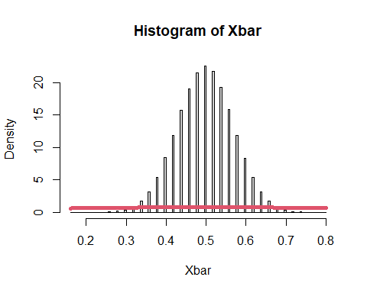

## [1] "the mean of x bar for prob = 0.5 n = 50 is : 0.50003536"  
## [1] "the mean of x distribution for prob = 0.5 n = 50 is : 0.5"  
## [1] "the variance of x bar for prob = 0.5 n = 50 is : 0.00499770954508949"  
## [1] "the variance of x distribution for prob = 0.5 n = 50 is : 0.05"   
## [2] "the variance of x distribution for prob = 0.5 n = 50 is : 0.025"   
## [3] "the variance of x distribution for prob = 0.5 n = 50 is : 0.00833333333333333"  
## [4] "the variance of x distribution for prob = 0.5 n = 50 is : 0.005"   
## [5] "the variance of x distribution for prob = 0.5 n = 50 is : 0.0025"   
## [6] "the variance of x distribution for prob = 0.5 n = 50 is : 0.00166666666666667"  
## [1] "for prob = 0.5 n = 100"

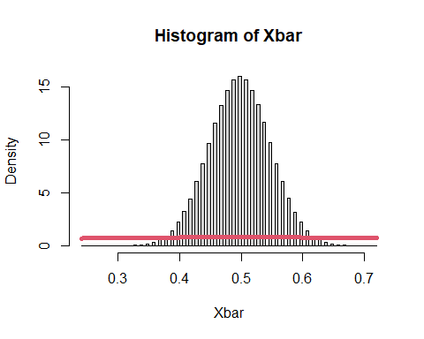

## [1] "the mean of x bar for prob = 0.5 n = 100 is : 0.50008864"  
## [1] "the mean of x distribution for prob = 0.5 n = 100 is : 0.5"  
## [1] "the variance of x bar for prob = 0.5 n = 100 is : 0.00250625355545751"  
## [1] "the variance of x distribution for prob = 0.5 n = 100 is : 0.05"   
## [2] "the variance of x distribution for prob = 0.5 n = 100 is : 0.025"   
## [3] "the variance of x distribution for prob = 0.5 n = 100 is : 0.00833333333333333"  
## [4] "the variance of x distribution for prob = 0.5 n = 100 is : 0.005"   
## [5] "the variance of x distribution for prob = 0.5 n = 100 is : 0.0025"   
## [6] "the variance of x distribution for prob = 0.5 n = 100 is : 0.00166666666666667"  
## [1] "for prob = 0.5 n = 150"

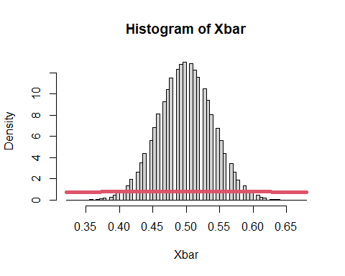

## [1] "the mean of x bar for prob = 0.5 n = 150 is : 0.5000024"  
## [1] "the mean of x distribution for prob = 0.5 n = 150 is : 0.5"  
## [1] "the variance of x bar for prob = 0.5 n = 150 is : 0.00166810786378906"  
## [1] "the variance of x distribution for prob = 0.5 n = 150 is : 0.05"   
## [2] "the variance of x distribution for prob = 0.5 n = 150 is : 0.025"   
## [3] "the variance of x distribution for prob = 0.5 n = 150 is : 0.00833333333333333"  
## [4] "the variance of x distribution for prob = 0.5 n = 150 is : 0.005"   
## [5] "the variance of x distribution for prob = 0.5 n = 150 is : 0.0025"   
## [6] "the variance of x distribution for prob = 0.5 n = 150 is : 0.00166666666666667"  
## [1] "for prob = 0.7 n = 5"

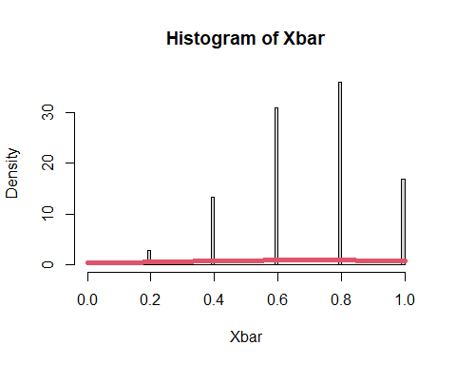

## [1] "the mean of x bar for prob = 0.7 n = 5 is : 0.7000352"  
## [1] "the mean of x distribution for prob = 0.7 n = 5 is : 0.7"  
## [1] "the variance of x bar for prob = 0.7 n = 5 is : 0.0419623226856054"  
## [1] "the variance of x distribution for prob = 0.7 n = 5 is : 0.042"   
## [2] "the variance of x distribution for prob = 0.7 n = 5 is : 0.021"   
## [3] "the variance of x distribution for prob = 0.7 n = 5 is : 0.007"   
## [4] "the variance of x distribution for prob = 0.7 n = 5 is : 0.0042"  
## [5] "the variance of x distribution for prob = 0.7 n = 5 is : 0.0021"  
## [6] "the variance of x distribution for prob = 0.7 n = 5 is : 0.0014"  
## [1] "for prob = 0.7 n = 10"

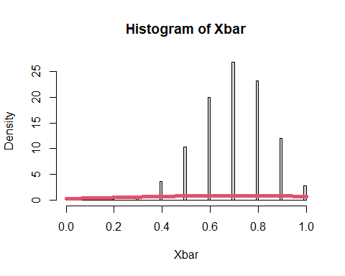

## [1] "the mean of x bar for prob = 0.7 n = 10 is : 0.6999552"  
## [1] "the mean of x distribution for prob = 0.7 n = 10 is : 0.7"  
## [1] "the variance of x bar for prob = 0.7 n = 10 is : 0.0209215998361596"  
## [1] "the variance of x distribution for prob = 0.7 n = 10 is : 0.042"   
## [2] "the variance of x distribution for prob = 0.7 n = 10 is : 0.021"   
## [3] "the variance of x distribution for prob = 0.7 n = 10 is : 0.007"   
## [4] "the variance of x distribution for prob = 0.7 n = 10 is : 0.0042"  
## [5] "the variance of x distribution for prob = 0.7 n = 10 is : 0.0021"  
## [6] "the variance of x distribution for prob = 0.7 n = 10 is : 0.0014"  
## [1] "for prob = 0.7 n = 30"

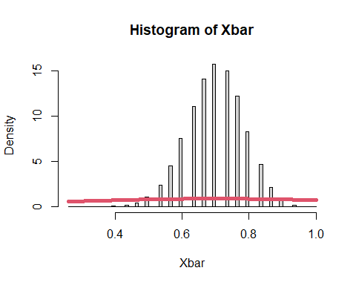

## [1] "the mean of x bar for prob = 0.7 n = 30 is : 0.699863866666667"  
## [1] "the mean of x distribution for prob = 0.7 n = 30 is : 0.7"  
## [1] "the variance of x bar for prob = 0.7 n = 30 is : 0.00703691109709332"  
## [1] "the variance of x distribution for prob = 0.7 n = 30 is : 0.042"   
## [2] "the variance of x distribution for prob = 0.7 n = 30 is : 0.021"   
## [3] "the variance of x distribution for prob = 0.7 n = 30 is : 0.007"   
## [4] "the variance of x distribution for prob = 0.7 n = 30 is : 0.0042"  
## [5] "the variance of x distribution for prob = 0.7 n = 30 is : 0.0021"  
## [6] "the variance of x distribution for prob = 0.7 n = 30 is : 0.0014"  
## [1] "for prob = 0.7 n = 50"

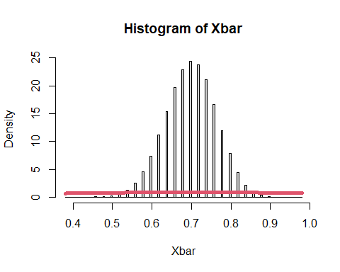

## [1] "the mean of x bar for prob = 0.7 n = 50 is : 0.7000562"  
## [1] "the mean of x distribution for prob = 0.7 n = 50 is : 0.7"  
## [1] "the variance of x bar for prob = 0.7 n = 50 is : 0.00420388604933209"  
## [1] "the variance of x distribution for prob = 0.7 n = 50 is : 0.042"   
## [2] "the variance of x distribution for prob = 0.7 n = 50 is : 0.021"   
## [3] "the variance of x distribution for prob = 0.7 n = 50 is : 0.007"   
## [4] "the variance of x distribution for prob = 0.7 n = 50 is : 0.0042"  
## [5] "the variance of x distribution for prob = 0.7 n = 50 is : 0.0021"  
## [6] "the variance of x distribution for prob = 0.7 n = 50 is : 0.0014"  
## [1] "for prob = 0.7 n = 100"

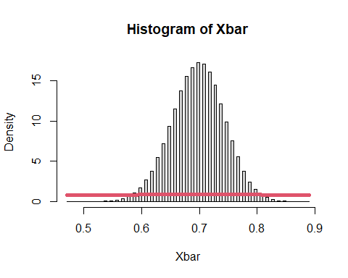

## [1] "the mean of x bar for prob = 0.7 n = 100 is : 0.69994772"  
## [1] "the mean of x distribution for prob = 0.7 n = 100 is : 0.7"  
## [1] "the variance of x bar for prob = 0.7 n = 100 is : 0.00210183947048054"  
## [1] "the variance of x distribution for prob = 0.7 n = 100 is : 0.042"   
## [2] "the variance of x distribution for prob = 0.7 n = 100 is : 0.021"   
## [3] "the variance of x distribution for prob = 0.7 n = 100 is : 0.007"   
## [4] "the variance of x distribution for prob = 0.7 n = 100 is : 0.0042"  
## [5] "the variance of x distribution for prob = 0.7 n = 100 is : 0.0021"  
## [6] "the variance of x distribution for prob = 0.7 n = 100 is : 0.0014"  
## [1] "for prob = 0.7 n = 150"

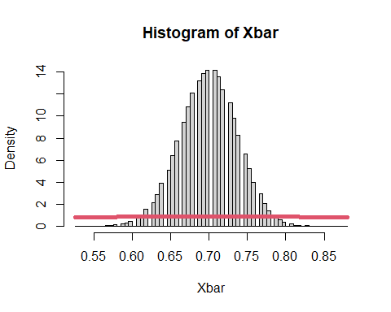

## [1] "the mean of x bar for prob = 0.7 n = 150 is : 0.699945626666667"  
## [1] "the mean of x distribution for prob = 0.7 n = 150 is : 0.7"  
## [1] "the variance of x bar for prob = 0.7 n = 150 is : 0.00140021513285978"  
## [1] "the variance of x distribution for prob = 0.7 n = 150 is : 0.042"   
## [2] "the variance of x distribution for prob = 0.7 n = 150 is : 0.021"   
## [3] "the variance of x distribution for prob = 0.7 n = 150 is : 0.007"   
## [4] "the variance of x distribution for prob = 0.7 n = 150 is : 0.0042"  
## [5] "the variance of x distribution for prob = 0.7 n = 150 is : 0.0021"  
## [6] "the variance of x distribution for prob = 0.7 n = 150 is : 0.0014"  
## [1] "for prob = 0.9 n = 5"

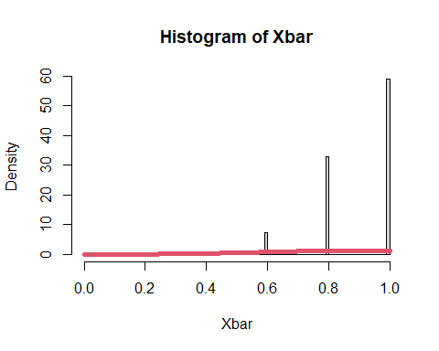

## [1] "the mean of x bar for prob = 0.9 n = 5 is : 0.9001712"  
## [1] "the mean of x distribution for prob = 0.9 n = 5 is : 0.9"  
## [1] "the variance of x bar for prob = 0.9 n = 5 is : 0.0179729666364933"  
## [1] "the variance of x distribution for prob = 0.9 n = 5 is : 0.018"   
## [2] "the variance of x distribution for prob = 0.9 n = 5 is : 0.009"   
## [3] "the variance of x distribution for prob = 0.9 n = 5 is : 0.003"   
## [4] "the variance of x distribution for prob = 0.9 n = 5 is : 0.0018"  
## [5] "the variance of x distribution for prob = 0.9 n = 5 is : 9e-04"   
## [6] "the variance of x distribution for prob = 0.9 n = 5 is : 6e-04"   
## [1] "for prob = 0.9 n = 10"

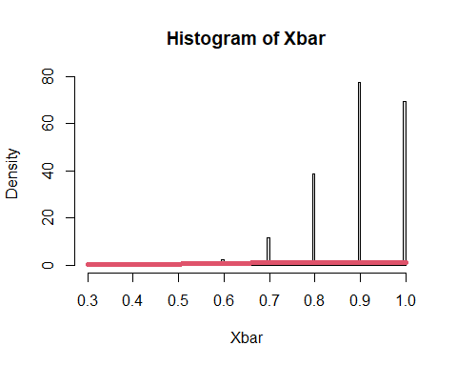

## [1] "the mean of x bar for prob = 0.9 n = 10 is : 0.8998236"  
## [1] "the mean of x distribution for prob = 0.9 n = 10 is : 0.9"  
## [1] "the variance of x bar for prob = 0.9 n = 10 is : 0.00900814689933379"  
## [1] "the variance of x distribution for prob = 0.9 n = 10 is : 0.018"   
## [2] "the variance of x distribution for prob = 0.9 n = 10 is : 0.009"   
## [3] "the variance of x distribution for prob = 0.9 n = 10 is : 0.003"   
## [4] "the variance of x distribution for prob = 0.9 n = 10 is : 0.0018"  
## [5] "the variance of x distribution for prob = 0.9 n = 10 is : 9e-04"   
## [6] "the variance of x distribution for prob = 0.9 n = 10 is : 6e-04"   
## [1] "for prob = 0.9 n = 30"

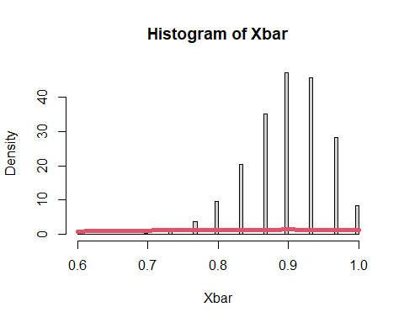

## [1] "the mean of x bar for prob = 0.9 n = 30 is : 0.900084266666667"  
## [1] "the mean of x distribution for prob = 0.9 n = 30 is : 0.9"  
## [1] "the variance of x bar for prob = 0.9 n = 30 is : 0.00299043888000665"  
## [1] "the variance of x distribution for prob = 0.9 n = 30 is : 0.018"   
## [2] "the variance of x distribution for prob = 0.9 n = 30 is : 0.009"   
## [3] "the variance of x distribution for prob = 0.9 n = 30 is : 0.003"   
## [4] "the variance of x distribution for prob = 0.9 n = 30 is : 0.0018"  
## [5] "the variance of x distribution for prob = 0.9 n = 30 is : 9e-04"   
## [6] "the variance of x distribution for prob = 0.9 n = 30 is : 6e-04"   
## [1] "for prob = 0.9 n = 50"

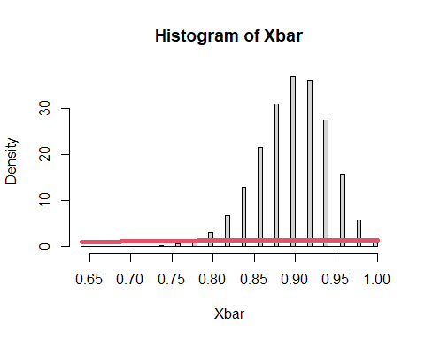

## [1] "the mean of x bar for prob = 0.9 n = 50 is : 0.89988304"  
## [1] "the mean of x distribution for prob = 0.9 n = 50 is : 0.9"  
## [1] "the variance of x bar for prob = 0.9 n = 50 is : 0.00180295312626465"  
## [1] "the variance of x distribution for prob = 0.9 n = 50 is : 0.018"   
## [2] "the variance of x distribution for prob = 0.9 n = 50 is : 0.009"   
## [3] "the variance of x distribution for prob = 0.9 n = 50 is : 0.003"   
## [4] "the variance of x distribution for prob = 0.9 n = 50 is : 0.0018"  
## [5] "the variance of x distribution for prob = 0.9 n = 50 is : 9e-04"   
## [6] "the variance of x distribution for prob = 0.9 n = 50 is : 6e-04"   
## [1] "for prob = 0.9 n = 100"

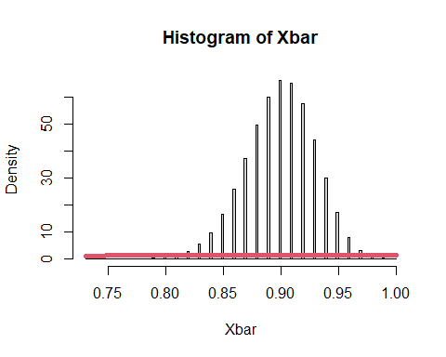

## [1] "the mean of x bar for prob = 0.9 n = 100 is : 0.89997128"  
## [1] "the mean of x distribution for prob = 0.9 n = 100 is : 0.9"  
## [1] "the variance of x bar for prob = 0.9 n = 100 is : 0.000901611778385157"  
## [1] "the variance of x distribution for prob = 0.9 n = 100 is : 0.018"   
## [2] "the variance of x distribution for prob = 0.9 n = 100 is : 0.009"   
## [3] "the variance of x distribution for prob = 0.9 n = 100 is : 0.003"   
## [4] "the variance of x distribution for prob = 0.9 n = 100 is : 0.0018"  
## [5] "the variance of x distribution for prob = 0.9 n = 100 is : 9e-04"   
## [6] "the variance of x distribution for prob = 0.9 n = 100 is : 6e-04"   
## [1] "for prob = 0.9 n = 150"

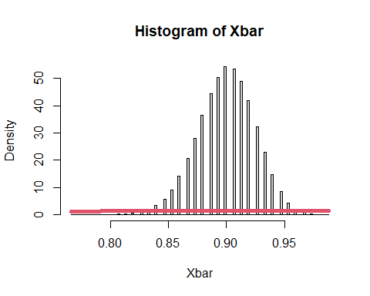

## [1] "the mean of x bar for prob = 0.9 n = 150 is : 0.899960226666667"  
## [1] "the mean of x distribution for prob = 0.9 n = 150 is : 0.9"  
## [1] "the variance of x bar for prob = 0.9 n = 150 is : 0.000599323616729189"  
## [1] "the variance of x distribution for prob = 0.9 n = 150 is : 0.018"   
## [2] "the variance of x distribution for prob = 0.9 n = 150 is : 0.009"   
## [3] "the variance of x distribution for prob = 0.9 n = 150 is : 0.003"   
## [4] "the variance of x distribution for prob = 0.9 n = 150 is : 0.0018"  
## [5] "the variance of x distribution for prob = 0.9 n = 150 is : 9e-04"   
## [6] "the variance of x distribution for prob = 0.9 n = 150 is : 6e-04"